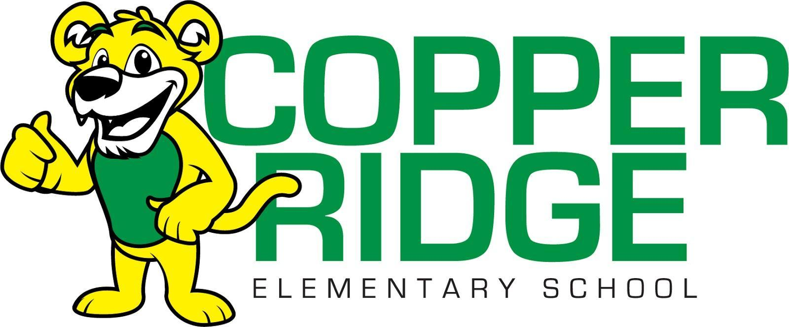

**Copper Ridge Elementary Second Grade** 

**2025-2026 Supply List**

**Please label highlighted supplies with a permanent marker**

Backpack **(non-rolling)**

clipboard

zipper pouch

24 pack of Crayola crayons (2)

scissors

Headphones (no ear buds please)

Water bottle with push/flip sports lid (not metal)

Avery 1 inch front slip white binder

Crayola markers broadline 10 pack (1)

Colored pencils 12 pack (1)

Clorox wipes (2)

glue sticks (6)

Kleenex (3)